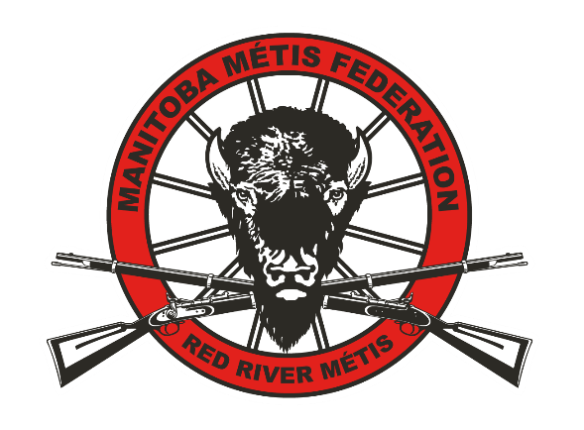
Red River Métis Business Association

Membership Application

First Name____________________ Surname_________________________
Business Name & Address _________________________________________

Mailing Address ________________________________________________

Type of Business _____________________ MMF Citizenship # ___________
Phone #_________________ Email _________________________________
Business Website ____________________ Company Size (# of employees) ____
Is your business registered on the Métis Business Association? Yes / No
https://online-directory.lrcc.mb.ca/

In joining the Red River Métis Business Association what programs / services would you most like to have available as a member? ☐ Networking ☐ Events ☐ Benefits
☐Social Media Services ☐Bookkeeping Services ☐ Member Savings / Discounts
☐ Mentorship ☐ Other_______________________________________________

_____________________ _______________
Applicant’s Signature Date

For more information please contact:
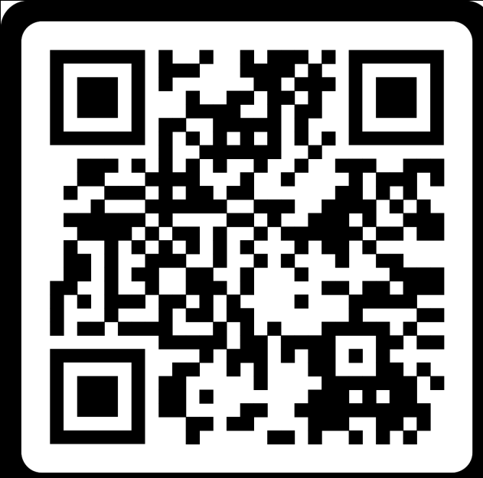 | Shaun Hampton – Manager  RRM Business Association  Shaun.hampton@mmf.mb.ca  204-589-0772 ext. 2242

